Procedure for Correct Placement of Calibrated Weight Plates on Weight Tree

**Document Number:** PRC-001

**Version Number:** 0.1

**Date of Issue:** July 15, 2024

**Author/Owner:** Michael Kingston

**Table of Contents**

1. Purpose
2. Scope
3. Definitions
4. Responsibilities
5. Procedure
6. Materials and Equipment
7. Safety and Environmental Considerations
8. Quality Control
9. References
10. Appendices
11. Revision History
12. **Purpose**

This procedure outlines the steps required to correctly place calibrated weight plates on the weight tree in ZeroW gyms, ensuring they are organized, easily accessible for users, and look great.

1. **Scope**

This procedure applies to all ZeroW gyms and covers the placement of Eleiko calibrated powerlifting plates and compression collars on weight trees. It does not cover the placement of other types of plates or equipment.

1. **Definitions**

* **Weight Tree:** A storage rack specifically designed to hold weight plates.
* **Calibrated Weight Plates:** High-precision weight plates used for powerlifting competition, manufactured by Eleiko.

1. **Responsibilities**

**Gym Managers:** Responsible for checking the weight trees at the beginning and end of each shift to ensure compliance with this procedure.

1. **Procedure**

**Step-by-Step Instructions**

* 1. **Check Inventory**

Verify the following inventory for each weight tree:

* 21x 25kg red plates
* 8x 20kg blue plates
* 4x 15kg yellow plates
* 6x 10kg green plates
* 6x 5kg white plates
* 6x 2.5kg black plates
* 4 1.25kg fractional plates
* 4x calibrated collars
  1. **Placement of Plates**

Place plates on the weight tree in the following order:

* Bottom Tier: 7x 25kg red plates on each side
* Second Tier (LHS): 7x 25kg red plates
* Second Tier (RHS): 8x 20kg blue plates
* Third Tier (LHS): 4x 15kg yellow plates (two on each side)
* Third Tier (RHS): 6x 10kg green plates (three on each side)
* Fourth Tier (LHS): 6x 5kg white plates (three on each side)
* Fourth Tier (RHS): 6x 2.5kg black plates (three on each side)
* Ensure that the plates are placed securely and evenly distributed on both sides of the weight tree.
  1. **Placement of Compression Collars & Fractional Plates**

- 2x pins for Place the 4x compression collars on the designated holder on the weight tree.

- 1x pin for the 4x 1.25kg fractional plates

* 1. **Verify Placement**
* Confirm that all plates and collars are correctly placed and secured on the weight tree.
* Check for any discrepancies in the number of plates or improper placement.
  1. **Document Any Issues**
* Record any missing plates or issues in the gym logbook and notify the appropriate personnel for resolution.

1. **Materials and Equipment**

* Eleiko calibrated powerlifting plates
* Weight tree
* Eleiko 1.25kg compression collars

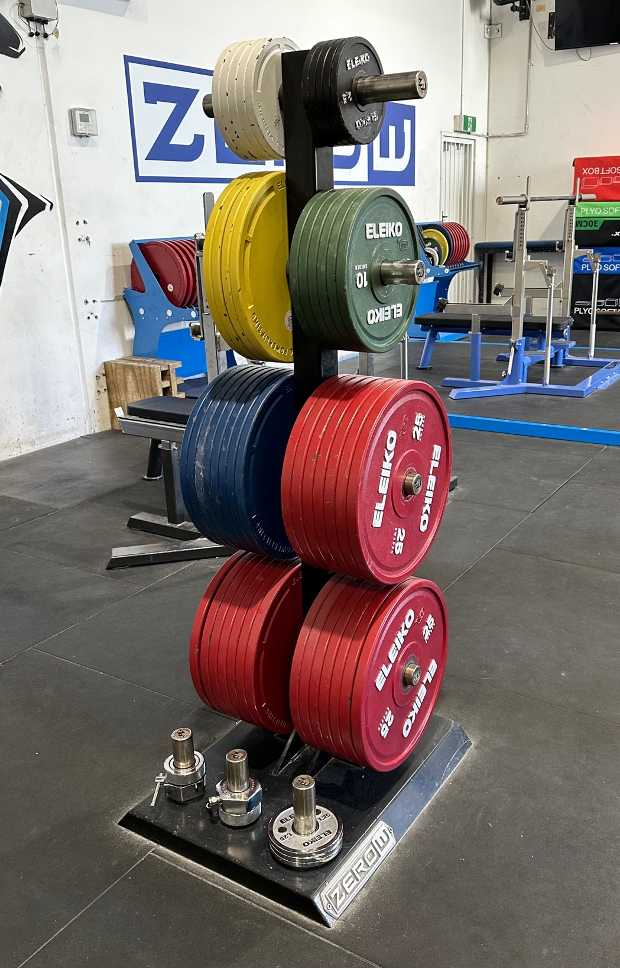

1. **Safety and Environmental Considerations**

* Ensure proper lifting techniques are used to prevent injury when placing plates on the weight tree.
* Keep the area around the weight tree clear to avoid tripping hazards.

1. **Quality Control**

* Gym managers must perform checks at the beginning and end of each shift to ensure compliance with this procedure.
* Any discrepancies or issues should be documented and addressed promptly.

1. **References**

* Eleiko Powerlifting Plates Specifications
* ZeroW Gym Equipment Guidelines

1. **Appendices**

* Appendix A: Weight Tree Diagram
* Appendix B: Sample Gym Logbook Entry

1. **Revision History**

|  |  |  |  |
| --- | --- | --- | --- |
| Version | Date | Description | Author |
| 0.1 | 15 July 2024 | Draft | Michael Kingston |